43 - 1.21

2 approaches (car example)

* conservative strategy: keeps what is in place and adapt what is new to current categories/regulations
* create new categories, new legislations that can also come from adapting/extending a law already in place

in technology:

* use what already exists in normative architecture
* create new categories

EU AI act

first regulation: immediately valid in all member states

real idea: as with GDPR it will be copied and implemented in other big marchets (become almost global)

lay down rules on AI, rules that balanced two things

* protection of fundamental rights and values
* the need for business and the markets

[52021PC0206 - EN - EUR-Lex](https://eur-lex.europa.eu/legal-content/EN/TXT/?uri=celex%3A52021PC0206)

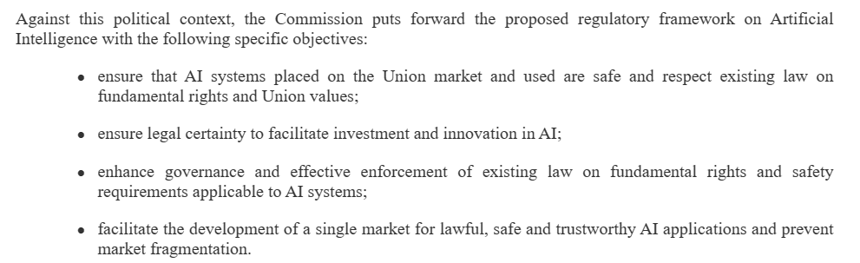

The EU started as a common market, proposal for regulation also business oriented. Can be something strong and also something weak (does not provided right for transparency, don’t let people to make a complaint)

3 parts

**part 1** aim of regulation

part 2: ai system in a risk based way

part 3: details about the governance and control

no hardware, just software. Limits to a given set of human defined sets. Ai agents might follow objectisve non explicitly programmed. Seems to be exlcuded from the regulation, can be a problem for new AI system.

EU AI act part 2: title 2 what’s prohibited

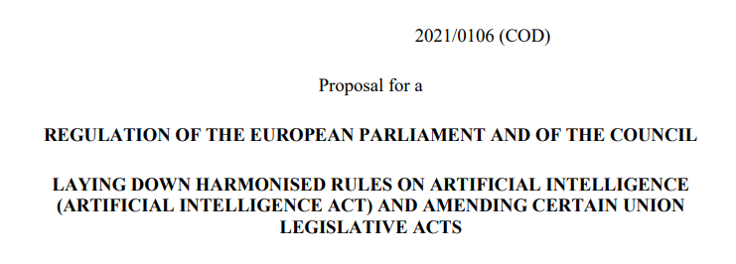

social scoring: